YEAR 10 BIOLOGICAL SCIENCE
BIOLOGICAL CHEMISTRY
BLOOD ALCOHOL LEVEL

AIM To determine which “blood samples” contain an alcohol level above the legal maximum.

METHOD 1. Filll a burette with 0.0200 molL⁻¹ potassium permanganate (KMnO₄) solution.

2. Pipette 20.00 mL of the “blood sample” A into a conical flask and add about
20.00 mL of 2.0 molL⁻¹ H₂SO₄.

3. Warm the conical flask to about 80 °C.

4. Record the initial level of KMnO₄ in the burette.

5. Run the KMnO₄ solution into the conical flask slowly while swirling it. Continue until the solution turns permanently pink. Turn off the burette tap and record the final volume of KMnO₄ in the burette.

6. Calculate the amount of KMnO₄ added by subtracting the initial volume from the final volume.

7. Use the graph provided to determine the alcohol content of the sample.

8. Repeat the procedure for samples B and C.

RESULTS

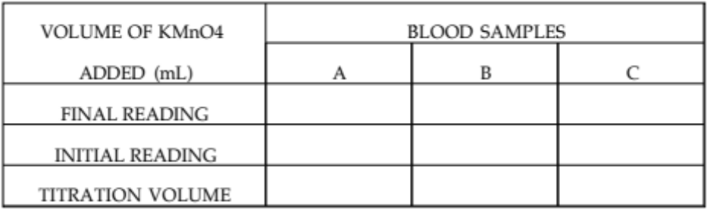

ALCOHOL READINGS Sample A

Sample B

Sample C

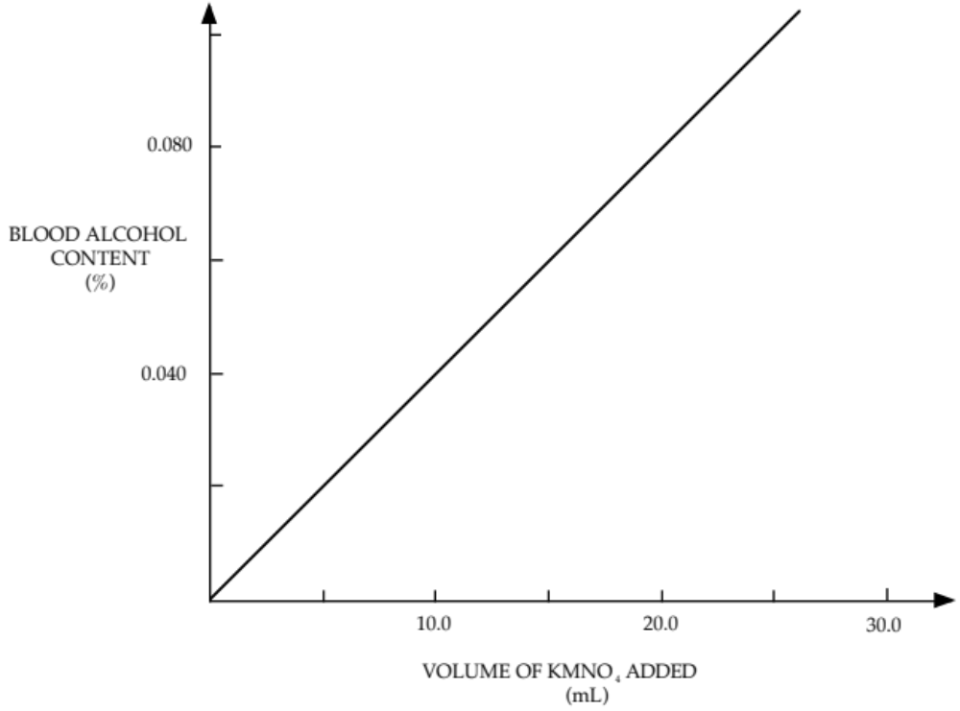

CONCLUSION

